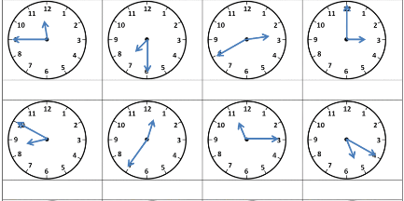

Vytvor otázky:
- you/go/ to school ...................................................................
- he/play/football ..................................................................
- when/my mum/relax ..................................................................
Prelož otázky a odpovedz:
- Máš rád pizzu? .................................................................
odpoveď ..................................................................
- Spievaš pesničky? .................................................................
odpoveď: No, ..........................................................
Odpovedz:

- Does your mum work in the evening?
No, ....................................................
- Does your dad watch TV at the weekend?
Yes, ...................................................



Vytvor otázky:
- you/go/ to school ...................................................................
- he/play/football ..................................................................
- when/my mum/relax ..................................................................
Prelož otázky a odpovedz:
- Máš rád pizzu? .................................................................
odpoveď ..................................................................
- Spievaš pesničky? .................................................................
odpoveď: No, ..........................................................
Odpovedz:

- Does your mum work in the evening?
No, ....................................................
- Does your dad watch TV at the weekend?
Yes, ...................................................

